**INTERSTATE CONTAINER CORPORATION** ***Date:* 11/11/2016** ***Spec #:*** ***Design #:*** **161320-01**

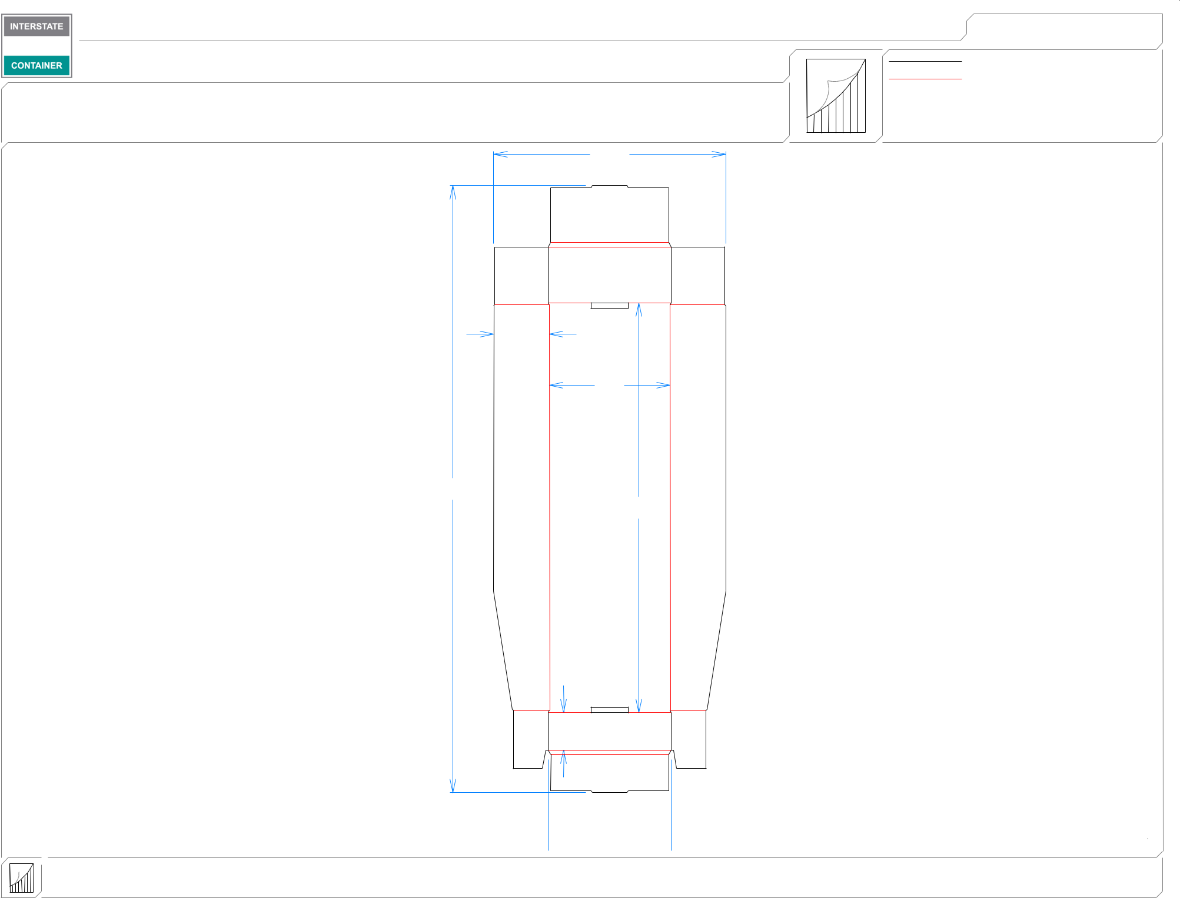

|  |  |  |  |  |  |  |  |
| --- | --- | --- | --- | --- | --- | --- | --- |
| ***Customer:*** | **DeMet's Candy** |  |  |  | ***Cut*** | **112 in.** |  |
| ***Description:* Tray -Shelf Ready TURTLES 17.5 oz Club Bag** | | | |  |  |
|  | ***Crease*** | **89 in.** |  |
| ***Style:* NJDC** |  | ***Revision Info:* [0] 11/09/2016:** | |  |  |
|  |  |  |  |  |
| ***I.D. :* 21+1/2 x 6+3/8 x 3** | | ***Blank size:*** | **32+3/4 x 12+1/2** |  |  |  |  |
| ***Board:* 32 B W** |  | ***Combination:*** | **36MW - 23M - 35HP** | ***Designer:*** | **Alan Groff** |  |  |
|  |  |  |  |  | 121*/*2 |  |  |
|  |  |  |  | 3 |  |  |  |
|  |  |  |  |  | 61*/*2 |  |  |
|  |  |  | 323*/*4 |  | 221*/*8 |  |  |
|  |  |  |  |  |  |  |

2

 65*/*8 

**inside view**

**Vertical Corrugation**

***notes:***

***Qty/unit:*** ***Area - waste:* 2.53 sq. ft** ***Waste on blank:* 10.6%** ***Piece weight - waste:* 0.26 lbs./119.97 g**